ITF KIDS’ DEVELOPMENT COURSE
General Information
The course is open to all ITF red belts and black belts (2nd Kup - 9th Degree)
Date: 28th & 29th July 2012
Place: Gimnasio Benialgar
C/ Mercado 5
03501 Benidorm
Alicante – Spain
Organiser: Federación Española de Taekwon-Do ITF (FEST)
http://www.taekwondo-itf-spain.com
Contact: Federación Española de Taekwon-Do ITF (FEST)
C/ Mercado 5
03501 Benidorm
Alicante – Spain
Phone: (+34) 96585 98 85
e-mail: info@taekwondo-itf-spain.com
Fee: €75 course fee + €50 inscription fee to be paid in the course.
Dinner €25 (optional)
Schedule:
Saturday 28th July 2012 | Sunday 29th July 2012
9h – 9h30 Registration | 8h30 – 12h TKD Program Course Part 3
9h30 – 13h TKD Program Course Part 1 | 12h – 13h Lunch break
13h – 14h Lunch break | 13 – 15h TKD Program Course Part 4
14h – 17h TKD Program Course Part 2 | 15h Departure
20h Dinner (optional)

Dress: Participants must wear tracksuit and trainers
Booking: To book a place in the course, please complete the application form and e-mail it to info@taekwondo-itf-spain.com by Friday 20th July 2012.

ITF KIDS’ DEVELOPMENT COURSE INVITATION
Dear ITF Grand Masters, Masters, Instructors and students,
We have the honour to invite you to the international ITF Kids’ Development Course to be held in Gimnasio Benialgar in the city of Benidorm in Spain.
Benidorm is one of the most touristic cities in Spain; you can find sunny sand beaches and summer temperatures all year round. Benidorm centre is a great place to visit for shopping, eating and drinking, nightlife, etc. Not far from Benidorm there are several them parks where the whole family can spend an enjoyable day. It takes 10 minutes to get to the city centre from the bus station or the AP7 motorway. There are direct bus connections to Alicante Airport. It is your great opportunity to combine your holiday with a KIDS COURSE
The course will be conducted by Master Nardizzi 8th degree, the Chairman of the ITF Children’s Development Committee.
The Taekwon-Do Kids Development Program (TKD Program) is the official ITF program for children aged 3 to 7 years. It teaches the children basic coordination skills and fundamental Taekwon-Do skills to yellow belt standard as well as life skills and character education. This is a great opportunity for you to adopt a formal programme for your children’s classes which is backed by the ITF. See the ITF website for more information about the TKD Program.
Each participant will receive one copy of the Study Book, one copy of the Instructor’s Guide and a certificate of participation from the ITF Children’s Development Committee. The course is also open to red belts to allow them to assist in classes which are adopting the TKD Program.
We hope you join us for this stimulating course which promises to bring a new dimension into your teaching strategy for children.

Paco Ferrando 4th Degree
President of Federación Española de Taekwon-Do ITF (FEST)

HOW TO GET THERE
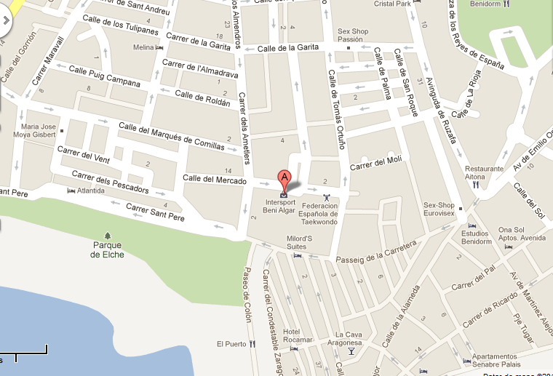
Gimnasio Benialgar
C/Mercado 5
03501 Benidorm
Alicante
Spain

Google maps link:
http://g.co/maps/v3hzu

By car:
Motorway AP-7. Exit 65 Benidorm Levante, and follow signs to “centro ciudad”. You can also reach the city centre through the National route N-332.

By train:
There are train stations in Alicante and Valencia which are connected to Benidorm by bus or tramway (Alicante - Benidorm).

By plane:
The nearest airport is Alicante (ALC) Altet Airport, 55km from Benidorm. Other possibilities are Valencia (VLC) Manises Airport and Murcia (MJV) San Javier Airport. From any of these airports it is possible to get to Benidorm by rental car or taxi, you can book them directly at the airport. Another cheaper possibility is using specialized companies: www.resorthoppa.com or www.shuttledirect.com. There are direct buses to from Alicante Airport to Benidorm: www. alsa.es.

Accomodation:
If you wish so, we can book your accommodation in Benidorm. Please, contact us for more information.

